1. Requirement
The system should allow a new user to register for access to https://ownwebsite.com/, so they can log in and use the site.
As this is a one-line requirement with no extra details, I have listed my own understanding as assumptions below, along with the questions I would ask the SME to confirm or correct them.

1.1 My Assumptions (to be confirmed with SME)
- Any visitor to the website can register — it is not limited to a specific group.
- Basic details needed are: name, email address, and password.
- Email address will be used as the login ID.
- The user's email needs to be verified before the account becomes active.
- The user must agree to Terms & Conditions before registering.
- Password should follow basic security rules (minimum length, etc.).
- Login, forgot password, and profile editing are separate requirements — not part of this one.

2. Questions I Would Ask the SME
I have grouped my questions using the 5W1H approach (Why, Who, What, When, How) so that I cover the requirement from every angle, without assuming too much on my own.

2.1 Understanding the Purpose (Why)
- Why do we need users to register — what does the business get out of it (leads, paid access, personalization)?
- What problem is this solving for the user right now?
- Is this a brand-new feature, or are we replacing/improving an existing registration process?

2.2 Understanding the Users (Who)
- Who will be using this registration form — general public, existing customers, or a specific group?
- Do we expect users to be comfortable with technology, or should the form be extra simple?
- Will this be used on mobile, desktop, or both?

2.3 Understanding What Information Is Needed (What)
- What details do we need from the user to register (name, email, phone number, etc.)?
- Which of these fields are compulsory and which are optional?
- Do we need to verify the user's email or phone number before they can use the account?

2.4 Understanding the Process (How)
- What happens step-by-step after the user clicks "Register"?
- What happens if the user enters an email that's already registered?
- Is there any approval step needed, or is the account active immediately?

2.5 Understanding Rules & Validations (How)
- Are there any rules for the password (length, special characters, etc.)?
- Do we need to show any Terms & Conditions or Privacy Policy that the user must agree to?
- Is there an age limit or any other eligibility condition for registering?

2.6 Understanding Success & Errors (What/When)
- What should the user see after successfully registering?
- What error messages should be shown if something goes wrong?
- How will we know if this feature is working well (any success metric)?

2.7 Understanding Look & Feel
- Is there a design or branding guide I should follow for this page?
- Are there similar pages/forms already built that I can use as a reference?

3. User Story
Field | Detail
Story ID | US-001
Title | New User Registration
User Story | As a new visitor to ownwebsite.com,  I want to register using my name, email, and a password,  So that I can create an account and log in to use the website.
Acceptance Criteria | 1. Given I am on the website, when I click Register, then I see a form asking for name, email, password, and confirm password.  2. Given I fill the form correctly and agree to Terms & Conditions, when I submit, then my account is created and I get a verification email.  3. Given I enter an email that is already registered, when I submit, then I see an error message telling me to log in instead.  4. Given I enter a weak password, when I submit, then I see a message telling me the password rules.  5. Given I click the verification link in my email, when it is valid, then my account becomes active and I can log in.
Out of Scope | Login, forgot password, profile update

4. Use Case
Field | Detail
Use Case ID | UC-001
Use Case Name | Register for Access to ownwebsite.com
Actor | New User (visitor)
Description | Lets a new visitor create an account on the website so they can log in later.
Precondition | User is not already logged in and does not have an existing account.
Postcondition | A new account is created and, once verified, becomes active so the user can log in.
Main Flow | 1. User goes to the Registration page.  2. System shows the registration form.  3. User fills in name, email, password, and confirms password.  4. User agrees to Terms & Conditions and submits the form.  5. System checks the details are valid and the email is not already used.  6. System creates the account and sends a verification email.  7. User clicks the link in the email.  8. System activates the account.  9. User is taken to the login page.
Alternate Flow | If the email is already registered, the system shows an error and suggests the user log in instead.
Exception Flow | If the verification link has expired, the system lets the user request a new one.

5. Supporting Information
These are simple visuals I made to show how I understood the requirement — a wireframe of the registration page and an activity diagram of the process.

5.1 Wireframe — Registration Page
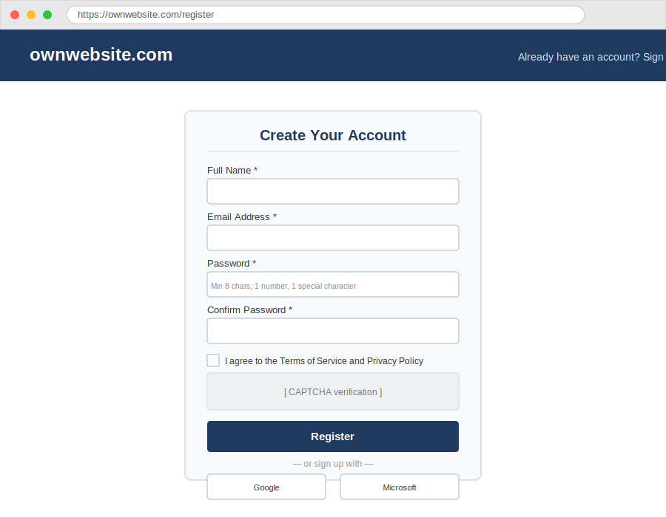
Figure 1: Registration page wireframe (draft)

5.2 Activity Diagram — Registration Process
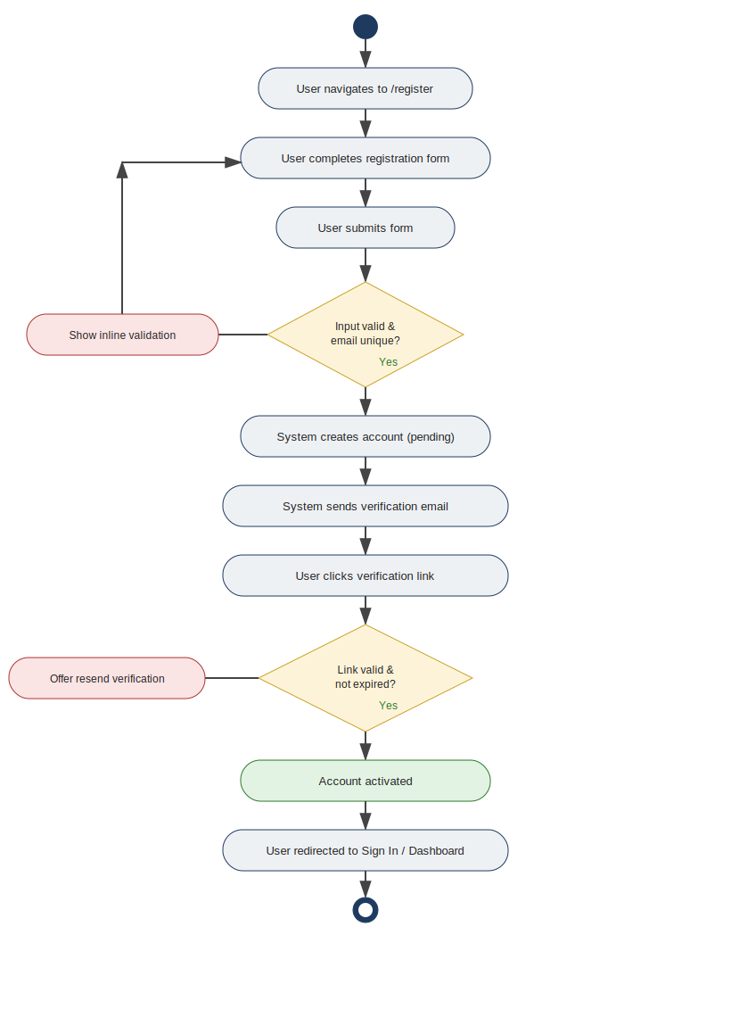
Figure 2: Registration activity diagram (draft)

5.3 What I Will Do Next
- Take these questions to the SME/Product Owner meeting and note down the answers.
- Update my assumptions, user story, and use case based on what SME confirms.
- Get the wireframe reviewed by the UX team before development starts.

